Space

🌟 Definition
# Source: AI Source: Provided by: [Data Path: Persons Table -> ID Column: 1, Name_En Column: Motasem Essam] -> From: [ChatGPT] on [5/30/2026]
Space is the division of pure mathematics that studies shapes, sizes, positions, dimensions, distances, and the properties of geometric objects and spaces.
It investigates how mathematical objects are arranged, how they relate spatially, and how geometric structures behave.
Historically, this division developed from geometry and has expanded to include many abstract types of spaces.

🎯 Purpose
# Source: AI Source: Provided by: [Data Path: Persons Table -> ID Column: 1, Name_En Column: Motasem Essam] -> From: [ChatGPT] on [5/30/2026]
- To study shapes and geometric objects
- To understand spatial relationships
- To analyze dimensions and distances
- To investigate geometric structures
- To describe and classify mathematical spaces

📚 Main Branches of Space

1. Euclidean Geometry
# Source: AI Source: Provided by: [Data Path: Persons Table -> ID Column: 1, Name_En Column: Motasem Essam] -> From: [ChatGPT] on [5/30/2026]
Studies geometric objects in ordinary flat space.
Topics
- Points
- Lines
- Angles
- Triangles
- Circles
- Polygons
Example
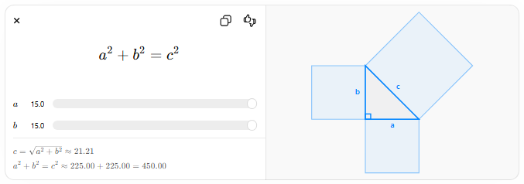
$$a^{2}+b^{2}=c^{2}$$
$$a$$
$$b$$
$$c=\sqrt{a^{2}+b^{2}}≈21.21$$
$$a^{2}+b^{2}=c^{2}≈225.00+225.00=450.00$$

2. Analytic Geometry
# Source: AI Source: Provided by: [Data Path: Persons Table -> ID Column: 1, Name_En Column: Motasem Essam] -> From: [ChatGPT] on [5/30/2026]
Studies geometry using coordinates and algebra.
Topics
- Coordinate systems
- Lines
- Conic sections
- Distance formulas
- Geometric equations
Example
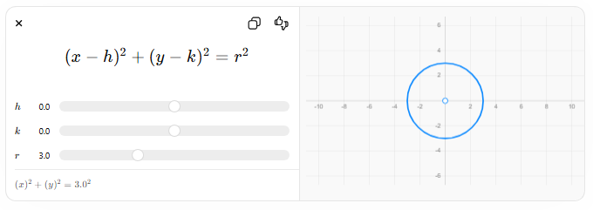
$$\left(x-h)^{2}+(y-k)^{2}=r^{2}\right.$$
$$h$$
$$k$$
$$r$$
$$\left(x)^{2}+(y)^{2}={3.0}^{2}\right.$$

3. Differential Geometry
# Source: AI Source: Provided by: [Data Path: Persons Table -> ID Column: 1, Name_En Column: Motasem Essam] -> From: [ChatGPT] on [5/30/2026]
Studies curves, surfaces, and smooth spaces using calculus.
Topics
- Curves
- Surfaces
- Curvature
- Manifolds
- Geodesics
Applications
- Physics
- General relativity
- Advanced geometry

4. Topology
# Source: AI Source: Provided by: [Data Path: Persons Table -> ID Column: 1, Name_En Column: Motasem Essam] -> From: [ChatGPT] on [5/30/2026]
Studies properties of spaces that remain unchanged under continuous deformation.
Topics
- Continuity
- Connectedness
- Compactness
- Topological spaces
- Homeomorphisms
Example Question
- When are two shapes topologically equivalent?

5. Trigonometry
# Source: AI Source: Provided by: [Data Path: Persons Table -> ID Column: 1, Name_En Column: Motasem Essam] -> From: [ChatGPT] on [5/30/2026]
Studies relationships between angles and lengths.
Topics
- Sine
- Cosine
- Tangent
- Trigonometric identities
- Triangles
Example
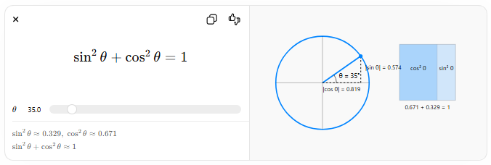
$${sin⁡}^{2}θ+{cos⁡}^{2}θ=1$$
$$θ$$
$${sin⁡}^{2}θ≈0.329, {cos⁡}^{2}θ≈0.671$$
$${sin⁡}^{2}θ+{cos⁡}^{2}θ≈1$$
θ = 35°|cos θ| = 0.819|sin θ| = 0.574cos² θsin² θ0.671 + 0.329 = 1

🧩 Main Mathematical Objects Studied
# Source: AI Source: Provided by: [Data Path: Persons Table -> ID Column: 1, Name_En Column: Motasem Essam] -> From: [ChatGPT] on [5/30/2026]
- Points
- Lines
- Angles
- Curves
- Surfaces
- Circles
- Polygons
- Manifolds
- Geometric spaces

🔑 Fundamental Concepts
# Source: AI Source: Provided by: [Data Path: Persons Table -> ID Column: 1, Name_En Column: Motasem Essam] -> From: [ChatGPT] on [5/30/2026]
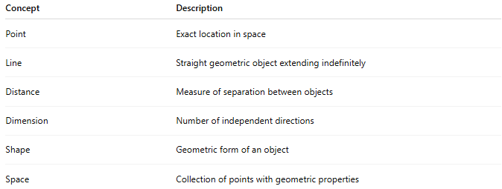
Concept | Description
Point | Exact location in space
Line | Straight geometric object extending indefinitely
Distance | Measure of separation between objects
Dimension | Number of independent directions
Shape | Geometric form of an object
Space | Collection of points with geometric properties

✏️ Example Questions
# Source: AI Source: Provided by: [Data Path: Persons Table -> ID Column: 1, Name_En Column: Motasem Essam] -> From: [ChatGPT] on [5/30/2026]
- What is the shortest distance between two points?
- What properties does a circle have?
- How can shapes be classified?
- How many dimensions does a space have?
- When are two spaces equivalent?

🔗 Relationship to Other Divisions of Pure Mathematics
# Source: AI Source: Provided by: [Data Path: Persons Table -> ID Column: 1, Name_En Column: Motasem Essam] -> From: [ChatGPT] on [5/30/2026]
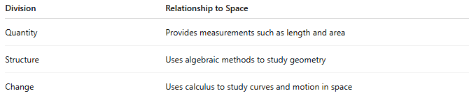
Division | Relationship to Space
Quantity | Provides measurements such as length and area
Structure | Uses algebraic methods to study geometry
Change | Uses calculus to study curves and motion in space

🧠 Simple Analogy
# Source: AI Source: Provided by: [Data Path: Persons Table -> ID Column: 1, Name_En Column: Motasem Essam] -> From: [ChatGPT] on [5/30/2026]
If:
- Quantity asks "How much?"
- Structure asks "How are things related?"
Then:
- Space asks "What shape does it have?" and "Where is it located?"

🧭 Summary
# Source: AI Source: Provided by: [Data Path: Persons Table -> ID Column: 1, Name_En Column: Motasem Essam] -> From: [ChatGPT] on [5/30/2026]
Space is the division of pure mathematics that studies shapes, dimensions, distances, positions, and geometric spaces. Its main branches include Euclidean geometry, analytic geometry, differential geometry, topology, and trigonometry, providing the mathematical foundation for understanding spatial structures and geometric relationships.

